ASSIGNMENT 6.4
Name: K.Uma Maheshwari
2303A52430
Batch: 44
Scenario Task 1: Student Performance Evaluation System .You are building a simple academic management module for a university system where student performance needs to be evaluated automatically.
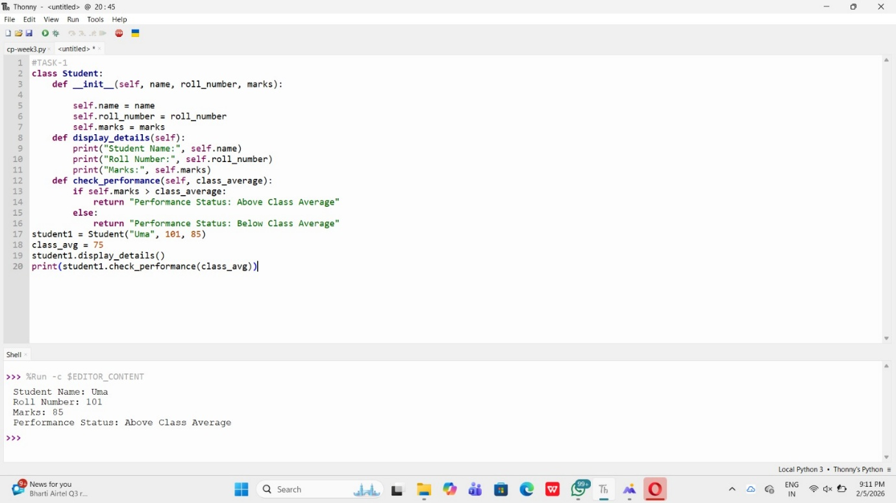

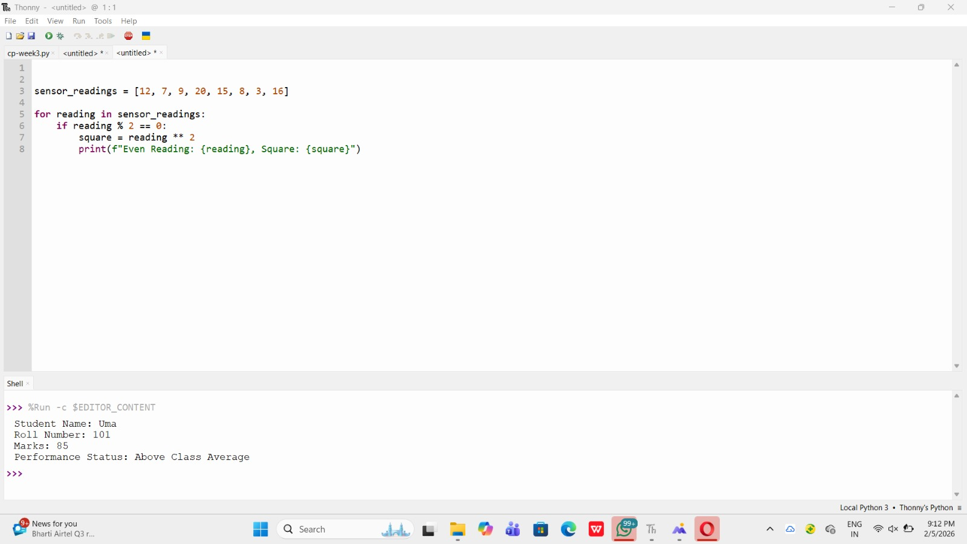
Task 2: Data Processing in a Monitoring System Scenario: You are working on a basic data monitoring script where sensor readings are collected as numbers. Only even readings need further processing.
Task 3: Banking Transaction Simulation
Scenario: You are developing a basic banking module that handles deposits and withdrawals for customers
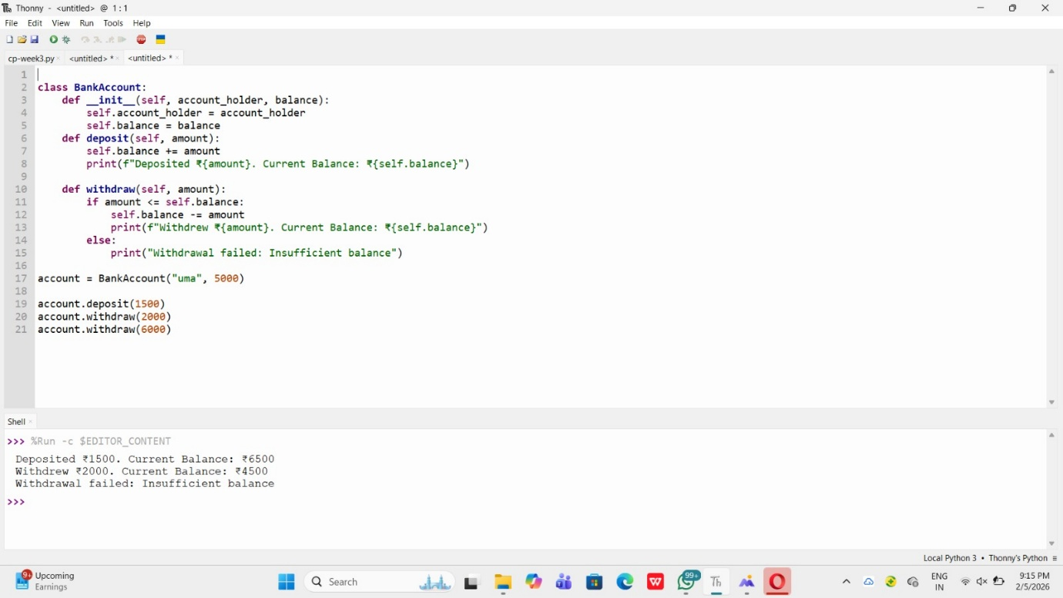

Task 4: Student Scholarship Eligibility Check
Scenario: A university wants to identify students eligible for a merit-basedscholarship based on their scores.

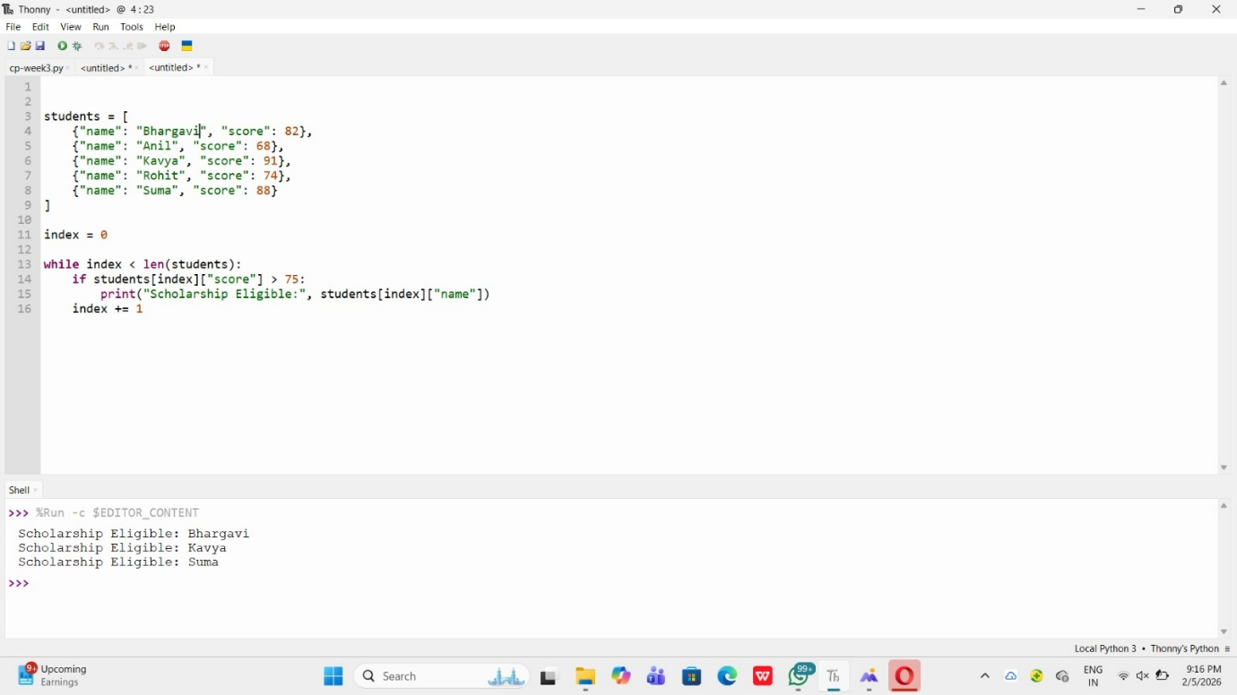

Task 5: Online Shopping Cart Module

Scenario: You are designing a simplified shopping cart system for an e-commerce website that supports item management and discount calculation
